Isha Chatbot Setup Guide

How to Run the AI Chatbot (Isha)
Step 1: Install Requirements
- Download Ollama
Visit https://ollama.com/download and download the installer for your operating system.
Follow the on-screen instructions to complete the installation.
- Verify the Installation
Open Command Prompt (Windows) or Terminal (macOS/Linux) and type:
- Ollama
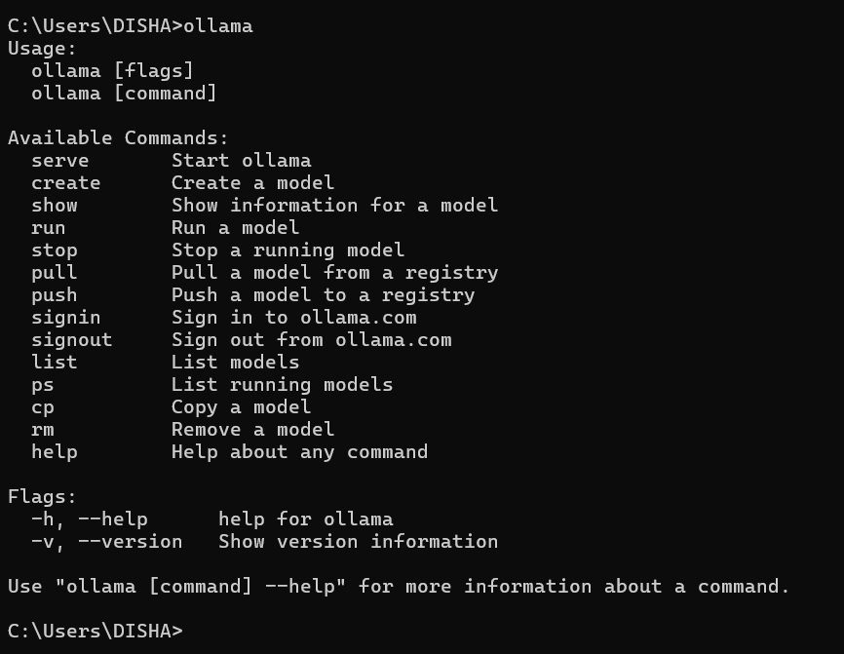
If the installation is successful, you should see output similar to the Ollama help screen.
- Download the Local Model
Isha uses the Llama 3.1 model. To install it, run:
- ollama pull llama3.1
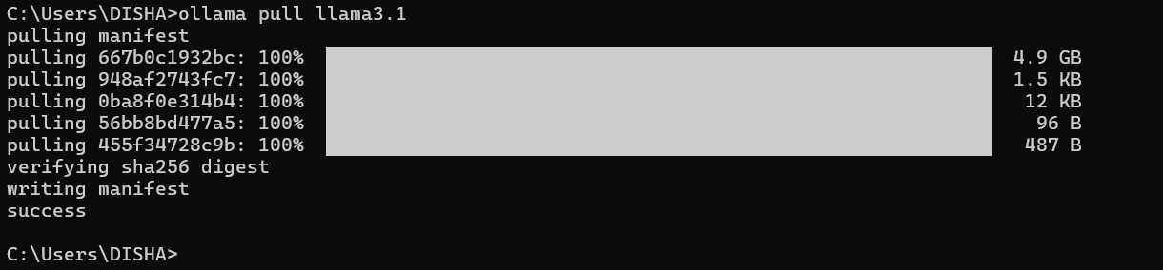
This process may take a few minutes. Once completed, you’ll see a confirmation message.

Step 2: Run the Chatbot in Command Line Mode
- Navigate to the project folder where your main.py file is located.
- Run the chatbot with the following command:
- python main.py
- You can now chat with the chatbot directly in the command line.
- To exit the chatbot, simply type:
- exit

Step 3: Run the Chatbot with GUI (Graphical User Interface)
- Open the app.py file in your terminal or IDE.
- Run the file with:
- python app.py
- Once it runs, you’ll see an address such as:
- http://127.0.0.1:5000
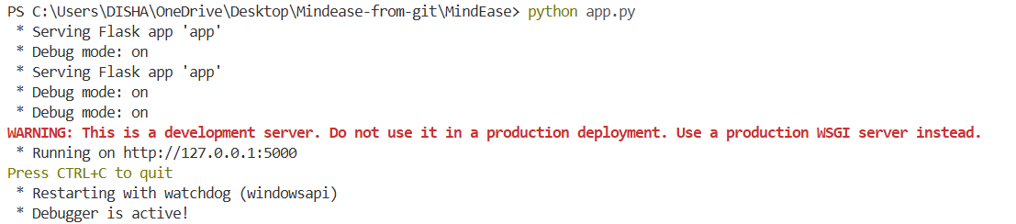
Click the link (or paste it in your browser) to open the chatbot interface.

Precautions Before Running
- Do not run any HTML file at the same time.
- Make sure VS Code’s Live Server (port 5500) is closed before running the chatbot.
- If you’re rerunning the chatbot, follow these steps again:
  - ollama
  - ollama pull llama3.1
  - python app.py
  - Ensure all other files are closed before clicking the Run button.

Step 4: Start Chatting
- When prompted, first tell the chatbot your name.
- Then start your conversation.

If you encounter any errors:
- Recheck all four steps above.
- Make sure Ollama and Llama 3.1 are installed correctly.
- Then rerun the chatbot.

Additional Resources
For video guidance on downloading and installing Ollama and Llama, visit YouTube and search for:
“How to install Ollama and Llama 3.1”

✅ You’re all set!
Once your chatbot is running smoothly, you can also experiment with other files like home.html.

